Abstract

This paper proposes a machine learning system aiming to predict the behaviour of five major Dhaka Stock Exchange (DSE) stocks: GP, SQUAREPHARMA, BATBC, BRACBANK, and BEXIMCO. The system integrates RSI, Moving Averages, and Volatility along with news sentiment derived from a synthetic dataset containing news headlines. The dataset comprises two years of historical OHLC (Open, High, Low, Close) prices, trading volumes, news headlines, sentiment scores, and news frequency metrics. The system utilizes classification models for directional changes (up/down) and a regression model for predicting the exact price. For the classification section, the system utilizes Logistic Regression, SVM, XGBoost, and Random Forest, where the Random Forest classifier emerges as the best-performing model. Whereas the Random Forest Regressor successfully estimates future prices. This paper uses a visualisation tool to better comprehend the movements in the stock market by displaying historical data alongside predicted probabilities. As a result, this project will serve as a decision-support system by providing probabilistic insights into the stock market for early investors.
Index Terms

Introduction

The stock market encompasses a huge amount of wealth. According to Barro, the stock market has opened up a viable opportunity for investments[5]. Consequently, predicting stock market changes has always been a complex yet enticing challenge over the years. The stock market comprises diverse factors that affect the market in a variety of ways, such as historical trends and economic indicators. Furthermore, agreement between nations and the political environment it brings, acquisition or merging of companies, and news headlines that affect public sentiment, can influence the stock market in unanticipated ways [4]. Predicting movements in such a dynamic environment is already very difficult, and forecasting the exact closing prices puts forth a type of complexity that deserves the introduction of advanced machine learning models. Many investment companies have also tried to look for patterns in the stock market using different AI systems [1]. This paper aims to tackle this challenge by merging two approaches:
- Analyzing technical indicators derived from historical OHLCV (Open, High, Low, Close, Volume) data.
- Assess the influence of public sentiment derived from news headlines.

Objective:
- Developing a probabilistic predictive system for 5 major DSE stocks: GP, SQUAREPHARMA, BATBC, BRACBANK, and BEXIMCO.
- Implementing two prediction methods:
  - Classification models to predict up or down movements in the stock market for the next trading day.
  - A Regression model to predict the exact closing price of a stock for the next trading day.
- Provide a comparison of the performance of different machine learning models in the context of stock market prediction
- Creating an interactive decision support system with proper visualization for investors.

Literature Review:
Developing a stock analysis and prediction system, even for just five DSE shares, requires a foundational understanding of the market theories, the influence of macroeconomic factors and analysing existing works focusing on machine learning models and sentiment analysis in the context of stock market prediction.
Several economic theories prove the difficulty of price prediction in the context of the stock market. The Efficient Market Hypothesis (EMH) explains that achieving returns above the market average is impossible through technical analysis. The Random Walk theory aligns with this hypothesis and suggests that price changes are, in essence, random and unpredictable. Empirical studies on Dhaka Stock Exchange shares of different influential pharmaceuticals have examined the influence of macroeconomic determinants such as money supply, exchange rates and inflation. The findings highlight statistical irrelevance due to other factors like misuse of political power, public sentiment and market inefficiencies [2]. This affirms the need for advanced non-linear machine learning models that can capture market trends traditional linear regression models will miss.
Many studies have experimented with financial forecasting using machine learning models. One such study has experimented with Artificial Neural Networks (ANNs), Random Forest, Support Vector Machines (SVM), and Long Short-Term Memory (LSTM). ANNs are very useful when it comes to non-linear data where traditional linear regression models fails. Random Forest and SVM were used for both classification and regression, which closely aligns with the research of this paper. LSTM was used to model sequential time-series data by capturing long-term dependencies in price movements. The findings suggest huge potential for advanced machine learning models in financial forecasting [1].
But as discussed above, many other factors influence the stock market in unprecedented ways. Modern research ascertains that technical analysis using historical data is not sufficient for price prediction and is also influenced by market sentiment. One study has shown that utilization of Natural Language Processing (NLP) techniques for sentiment analysis improves the accuracy of stock price prediction. By using LSTM with news headlines, they have achieved an accuracy of 88%. This proves the effectiveness of sentiment analysis in the context of stock market analysis. This study has also introduced a graph-based approach to stock market prediction. They have denoted stocks as nodes and their relationships as edges. Using this method along with Graph Convolutional Networks (GCN), they have been able to capture structural information of stocks and have achieved results that outperform traditional Deep Neural Network implementations in the field of stock market analysis [3].

Dataset Description:
The dataset consists of two years of daily trading data for five major companies:

- GP (Grameenphone) - Telecommunications
- SQURPHARMA (Square Pharmaceuticals) - Pharmaceuticals
- BATBC (British American Tobacco Bangladesh) - Consumer goods
- BRACBANK (BRAC Bank) - Banking
- BEXIMCO - Conglomerate
In terms of features, the dataset contains:
- Date: Trading date (business days only)
- Code: Stock symbol identifier
- Open: Opening price of the trading day
- High: Highest price during the trading day
- Low: Lowest price during the trading day
- Close: Closing price of the trading day
- Volume: Number of shares traded

Methodology (Preprocessing, Training)
- Preprocessing: Feature Engineering is used for preprocessing to add technical indicators. The following features were added:
  - Return: 1-day and 5-day percentage change in closing price was added to capture momentum
  - The rolling 5-day standard deviation of daily returns was calculated and added to the dataset to measure market risk
  - 5-day and 10-day simple moving averages of the closing price were calculated and added to smooth out price trends
  - A 14-day RSI column was calculated and added to the dataset to identify overbought and oversold conditions.
- Training: For training, the paper focuses on two types of predictive models:
  - Classification models:
    - Logistic Regression: Logistic Regression, despite its name, is a binary classifier that takes a list of linear inputs and, through the use of a sigmoid function, maps the output to a 1/0 probabilistic output [8]. In the context of this paper, Logistic Regression takes a series of inputs like RSI, Moving Averages, and Sentiment scores and gives a 0 or 1 output denoting “Price up” or “Price down”.
    - Random Forest Classifier: Random Forest is an ensemble learning method that operates by creating multiple decision trees during training time [9]. Random Forest uses a method called “bagging” or “bootstrapping”, where each of the decision trees is trained on a random sample extracted from the dataset. This reduces overfitting because of the high variance in the datasets of the decision trees. A Random Forest Classifier uses majority votes for the outputs of the decision trees to reach a decision (Up or down).
    - Gradient Boosting Classifier: Gradient Boosting is another ensemble learning method that uses multiple decision trees called "weak learners". The "weak learners" are constantly corrected and build upon to create a strong predictive model. Unlike Random Forest, in Gradient Boosting an algorithm is used to cut losses from the previous decision tree to create the next procedurely generated decision tree. [6].
    - XGBoost Classifier: XGBoost, which is short for Extreme Gradient Boosting, is a scalable gradient boosting library that uses a sparsity-aware algorithm to parallelize computation during tree construction [10].
    - Support Vector Machine(SVM): SVM is a powerful supervised learning model that finds the optimal hyperplane between two classes to predict the outcome. SVM uses Kernels to project non-linear data onto a higher-dimensional space, making it possible to linearly separate two classes [7].
  - Regression model: The paper uses a Random Forest Regressor as the regression model for forecasting the exact closing price of a stock for the next day. The Random Forest Regressor works in the same way as its counterpart discussed above, except that the Regressor uses a mean average of the decision trees to reach an exact number instead of using majority voting.

Result Analysis:
The experimental results evaluate both the directional (up/down) classification task and the next-day price regression task for the five selected DSE stocks (GP, SQURPHARMA, BATBC, BRACBANK and BEXIMCO). This is done using the technical indicators and news-based features described earlier in the report.

1. Classification models (Up/Down prediction)
The binary target 𝑦upyup​ indicates whether the next day’s closing price is higher than the current day’s close. For classification, the data were split into training and test sets with an 80:20 ratio, using stratification on the target variable so that both classes (up and down) are represented proportionally in each split. The common feature set includes OHLCV values, short-term returns, volatility, moving averages, RSI and news-related features (sentiment score and headline count).
The performance of the five classifiers on the test set is summarised below:
- Logistic Regression
  - Accuracy ≈ 50.89%
  - F1 Score ≈ 0.422
  - ROC AUC ≈ 0.503
- Logistic Regression essentially acts as a linear benchmark. Its accuracy and ROC AUC are only marginally above a random 50% baseline, which shows that a purely linear decision boundary struggles to capture the non-linear relationships between technical indicators, sentiment and next-day direction. The relatively low F1 score indicates that the model is not particularly strong at balancing precision and recall across both classes, especially if the class distribution is not perfectly balanced.
- Random Forest Classifier
  - Accuracy ≈ 54.04%
  - F1 Score ≈ 0.540
  - ROC AUC ≈ 0.533
- The Random Forest classifier is the best-performing model among all classifiers. Its accuracy is about 3–4 percentage points higher than Logistic Regression, and the F1 score is also the highest. The fact that accuracy and F1 score are very close suggests that the model maintains a relatively balanced performance across both “up” and “down” classes, rather than heavily favouring one side. The ROC AUC of ~0.533, while still modest, indicates that the forest has learned some useful non-linear patterns from the feature set and is able to separate the two classes slightly better than chance. This supports the choice of Random Forest as the primary classification model in the system.

- Gradient Boosting Classifier
  - Accuracy ≈ 50.69%
  - F1 Score ≈ 0.498
  - ROC AUC ≈ 0.513
- Gradient Boosting performs slightly better than Logistic Regression in terms of F1 and ROC AUC but does not surpass the Random Forest. This suggests that, with the current hyperparameters and feature engineering, the boosted trees are capturing some structure in the data but are not fully exploiting the potential of the ensemble method. Further tuning (e.g., learning rate, number of estimators, depth of trees) could potentially improve this model.

- SVM (RBF kernel)
  - Accuracy ≈ 51.48%
  - F1 Score ≈ 0.483
  - ROC AUC ≈ 0.493
- The SVM with an RBF kernel slightly improves over Logistic Regression in terms of accuracy but achieves a ROC AUC below 0.5, meaning its probability ranking is actually worse than random in this configuration. This indicates that while the SVM occasionally predicts the correct class label, it does not provide a reliable probabilistic separation between the “up” and “down” classes. The relatively modest F1 score also reflects that the model does not handle both classes equally well, and its complex decision boundary may not be well aligned with the underlying structure of the data.

- XGBoost Classifier
  - Accuracy ≈ 48.52%
  - F1 Score ≈ 0.481
  - ROC AUC ≈ 0.510
- XGBoost underperforms compared to the other tree-based models on raw accuracy and F1 score, although the ROC AUC is slightly above 0.5. This combination suggests that XGBoost, using its current settings, is not optimally tuned for this dataset and may be either underfitting or over-regularised. Given that XGBoost is generally powerful when tuned carefully, this result highlights the importance of model selection and hyperparameter optimisation, rather than assuming that a more advanced algorithm will automatically outperform simpler ensembles.
Interpretation of classification results
Overall, all classification models cluster around 50% accuracy, which is very close to random guessing and is consistent with the theoretical difficulty of short-term stock direction prediction described in the literature review (e.g., Efficient Market Hypothesis and Random Walk theory).
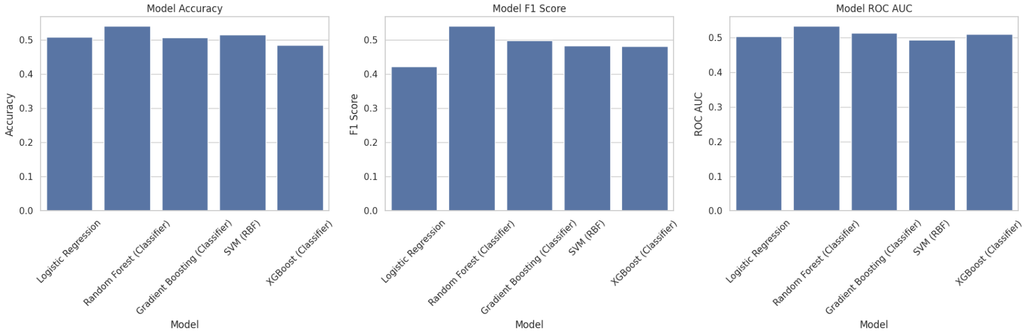
The Random Forest classifier does provide a small but consistent improvement over the baselines, which shows that incorporating non-linear relationships and interactions among technical and sentiment features adds some predictive value. However, the gains are not large enough to claim strong predictability of the DSE stocks’ next-day direction; instead, they indicate that the model can provide probabilistic guidance that should be combined with human judgment and risk management rather than used as a standalone trading rule.

2. Regression model (Next-day closing price)
For the regression task, the goal is to forecast the exact closing price for the next trading day. The same set of features is used, but here the continuous target is the next day’s close (Close𝑡+1Closet+1​). The data are again split into an 80:20 train-test division; unlike the classifier, the regression split uses shuffle=False so that the training portion contains earlier dates and the test set contains later dates. This avoids “looking into the future” and better reflects a realistic forecasting scenario.
A Random Forest Regressor with 300 trees is used as the regression model. Its performance on the held-out test set is:
- Mean Absolute Error (MAE) ≈ 13.30
- Coefficient of Determination 𝑅2R2 ≈ −0.17
The MAE of about 13.3 currency units means that, on average, the predicted next-day closing price deviates from the true price by around 13 units. Considering that many of the analysed shares trade in the range of roughly 100–300, this corresponds to an error band on the order of a few percent of the price level. For broad, high-level forecasts, this magnitude of error might still be useful as an indicative range rather than an exact point prediction.
However, the negative 𝑅2R2 score is an important signal: an 𝑅2R2 below zero indicates that the model performs worse than a simple baseline that always predicts the mean of the target variable. In other words, while the forest can produce reasonable individual predictions in some cases, it does not capture enough consistent structure to outperform a naive strategy over the entire test horizon. This is consistent with the highly noisy and non-stationary nature of stock prices, especially when forecasting only one day ahead.
From a practical perspective, the regression model should therefore be interpreted as a supporting tool that provides an approximate range and direction of expected price change, rather than a highly accurate oracle for exact closing prices.

3. Visual decision-support interface
Beyond raw metrics, the notebook implements an interactive visual component that turns the models into a decision-support tool for investors. For a selected stock code (e.g., “GP”), the system:
- Plots the last 60 trading days of the stock’s closing price.
- Overlays the predicted next-day closing price on the same chart.
- Prints a compact textual summary, including:
  - Last observed close price
  - Predicted next-day close and percentage change
  - Probability of an upward move from the Logistic Regression classifier
  - Latest day-level news sentiment and number of news headlines
  - A sample news headline from the synthetic dataset
For example, when the share code GP is selected, the interface reports:
- Last close price ≈ 232.25
- Predicted tomorrow close ≈ 231.74
- Expected change ≈ −0.22%
- Probability of price going up ≈ 49.41%
- Neutral sentiment and one related news headline
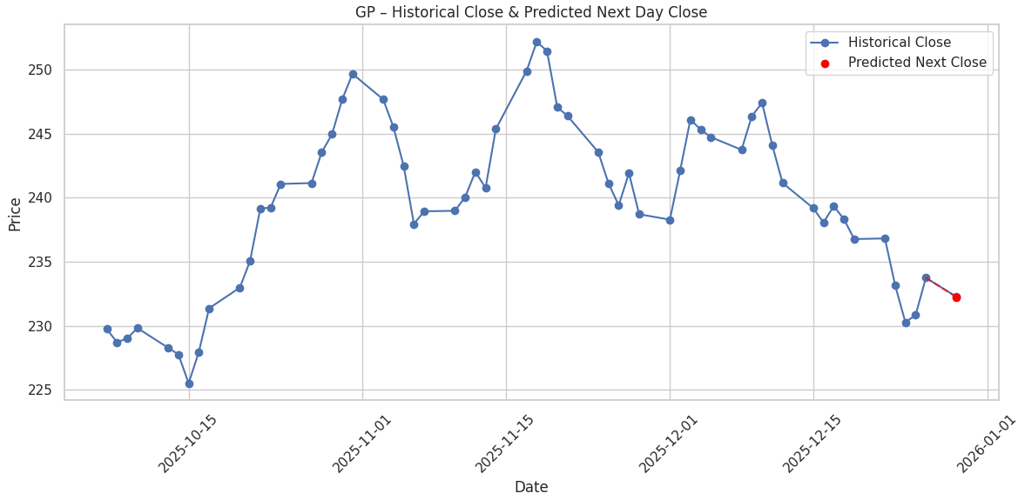
In the corresponding chart, the historical trajectory of GP’s close price over the past 60 days is shown as a line, and the predicted point for the next day is drawn as an extension of that line. This combination of numeric summary and visual context allows users to quickly see whether the prediction is suggesting a gradual continuation, a potential reversal, or minimal change relative to recent behaviour.
Even though the absolute accuracy of the models is limited, this interface adds value by aggregating multiple signals (technical indicators, sentiment features and model probabilities) into a format that is easy to understand and compare across different stocks.

4. Overall assessment
Taken together, the results show that:
- The Random Forest classifier provides the best directional predictive performance, slightly outperforming other models but still operating close to the theoretical limits imposed by market efficiency.
- The Random Forest Regressor can produce reasonable next-day price estimates in terms of average absolute error but fails to outperform a naive baseline globally, as indicated by the negative 𝑅2R2.
- The visualisation layer effectively translates these noisy yet informative model outputs into an interpretable dashboard for early investors, aligning with the project’s goal of building a decision-support system rather than a guaranteed profit-making engine.
Project Report
Thus, the result analysis confirms both the potential and the limitations of machine learning–based stock prediction on DSE data: while models can uncover subtle patterns and provide probabilistic guidance, the inherently volatile and information-rich nature of financial markets keeps truly precise and consistently superior predictions out of reach, reinforcing the need to use such models as one component in a broader investment decision process.

Limitations:
- Old news data limits the assessment of the true impact of news sentiment in the stock market.
- All models hover around 50% accuracy, leaving room for further optimization.
- The lack of macroeconomic indicators limits a comprehensive understanding of the stock market.
- Absence of global market data constrains the larger context of the stock market, limiting better performance.

Conclusion:
This research successfully developed and evaluated a stock price prediction system for five major DSE shares. This project highlights the potential of machine learning models in the context of financial forecasting. The successful integration of technical analysis and the interpretation of news sentiment proves the effectiveness of this approach for predicting stock exchange movements. The dual model implementation, classification for directional prediction and regression for exact price prediction, partnered with visualization of historical data against predicted values, provides investors with meaningful insights into the stock market. To sum up, the system proves to be a useful decision-support tool that can help users make informed data-driven decisions.

Bibliography:
- Machine Learning Stock Market Prediction Studies: Review and Research DirectionsMachine Learning Stock Market Prediction Studies: Review and Research Directions
- 18304010_BBA.pdf
- STOCK MARKET PREDICTION USING ENSEMBLE OF GRAPH THEORY, MACHINE LEARNING AND DEEP LEARNING MODELS
- The exchange rate effect of multi-currency risk arbitrage
- Stock Market and Investment | The Review of Financial Studies | Oxford Academic
- Greedy Function Approximation: A Gradient Boosting Machine
- Support-vector networks | Machine Learning
- What is Logistic Regression? | Definition from TechTarget
- Random Forests | Machine Learning
- 5537823.pdf

